Executive Summary
This document assesses how query performance will change under the proposed NAICS_All system, based on analysis of 967 existing catch-all records, a training exercise with three coders classifying 10 public sector contracts, and 350 simulated query evaluation. The evidence supports that service-level NAICS coding is ready for implementation with targeted handbook updates and guidance for researchers.
The Key Asymmetry: False negatives are invisible; false positives are visible and filterable. A researcher can filter out extra results but cannot discover missed contracts. This asymmetry makes reducing invisible misses more valuable than reducing visible extras, even when it means returning more results. More accurate NAICS coding standards will reduce the risk of inaccurate manual filtering.
Key Findings:
- False positives will decrease. Contracts currently miscategorized under catch-all codes (e.g., airports and ports appearing in road maintenance queries) will be excluded by specific operational codes.
- Recall for multi-service contracts will improve. Wide contracts covering multiple services will appear in all relevant queries, not just the one “primary” service they were assigned at data entry.
- Coders can consistently apply the new system. The training exercise showed high agreement when coders identified the same service, though sample sizes were small.
- Prefix queries are net beneficial. While querying for code families (e.g., 237xxx) returns more results than the exact codes, the additional results are adjacent services, not irrelevant contracts. The tradeoff favors recall (minimizing false negatives) over precision (minimizing false positives.) The Trade = PSD001 flag will restrict matches enough that code family queries will not overcapture false positives.
- Coding variation becomes measurable. Prefix queries capture 23% of variation automatically; remaining gaps become visible and addressable through further querying.

Visible Extras vs. Invisible Misses
Classification systems must balance between precision (minimizing false positives) and recall (minimizing false negatives.) For our purposes, the critical question is which type of error can the researcher detect and correct?
Figure I: Precision Vs. Recall Tradeoff
False Negatives (Missed Contracts) | False Positives (Extra Results)
INVISIBLE: researcher cannot detect | VISIBLE: researcher can see returned records and evaluate based on specific NAICS classifications
Cannot know what you’re missing | Can review and filter extra results

For example, a researcher who sees 50 results including 10 adjacent services can spend ~10 minutes reviewing and excluding them based on NAICS code and contract remarks. A researcher who sees 40 results has no way to know that 10 relevant contracts were coded differently and therefore missed.

Status Quo Performance Problems
The current single-code system creates two categories of query failures: false positives (irrelevant contracts appearing in query results,) and false negatives (relevant contracts not appearing in query results.) Analysis of public works contracts illustrates both problems.
False Positives: Catch-All Codes Capture Irrelevant Contracts
When staff classify multi-service public sector contracts, they use broad NAICS codes (i.e., 926120 for road maintenance.) These codes function as catch-alls that lump genuinely different industries together. For example, a researcher querying for road maintenance contracts receives:
Figure I: Results of Road Maintenance Query
Category | Count | Share
True road/highway contracts | 808 | 84%
Wide contracts (roads and other services) | 59 | 6%
Airports, ports, transit authorities | At least 100 | ~10%

The ~100 irrelevant contracts require institutional knowledge to identify. Under NAICS_All, these contracts receive airport/port/transit codes and are excluded from road queries.
False Negatives: Wide Contracts Invisible to Queries
When a contract covers multiple services, staff must choose one “primary” code. The contract becomes invisible to queries for other services.
Evidence from Wide 926120 Contracts Analysis:
At least 59 NAICS 926120 contracts are “genuinely wide,” covering road maintenance plus other services (water, sewer, parks, general facilities, etc.)
Figure II: Wide Contract Examples
Employer | Services Covered | Visible Under
Shawnee County, KS | Clerical, corrections, health, parks, public works | Road queries only
State of Montana DOT | Facilities maintenance, custodians, auto mechanics, lane striping, sign painting | Road queries only
NY State Thruway Authority | Highway maintenance, clerical, toll collectors, radio dispatchers | Road queries only

A researcher querying for “parks contracts” will never find Shawnee County, and has no way to know it exists. This invisible false negative is more damaging than a false positive that can be manually filtered.
Zero Capture of Secondary Services:
Under the status quo, each contract appears in exactly one query family. Multi-service contracts are findable only under their assigned primary service at data entry.

What the Training Exercise Shows
Three coders independently classified services from 10 public sector contracts across two rounds. The exercise tested whether codes could reliably identify and classify multiple services per contract.
Figure III: Study Design
Element | Description
Contracts | 10 public works contracts of varying complexity
Coders | Dylan, Greg, and Will working independently
Round 1 | 7 contracts; initial handbook; role-oriented framing
Round 2 | 3 contracts; revised handbook with clearer operational/administrative guidance; service-oriented framing; completed after team discussion of Round 1 results
Total observations | 272 classification decisions; 74 service-level comparisons where 2+ coders identified the same service

Two Stages of Agreement
Multi-service coding based on contract text involves two sequential processes, defined here. Failure to identically code a given contract can arise in either, or both, of these processes.
Stage 1: Identification agreement: given the contract text, coders must identify which services are covered by a given contract.
- In general, Stage 1 agreement is partial. Only ~16% of services were identified by all three coders and ~49% by two or more. Most services (51%) were only identified by one coder. This reflects a) different thoroughness levels, and b) interpretive choices about what constitutes a distinct service.
Stage 2: Classification agreement: given an identified service covered by the contract, coders must classify the service with the correct NAICS code.
- Stage 2 agreement improved markedly from 48% (Round 1) to 94% (Round 2.) This is the primary metric for classification reliability.
Irrelevant False Positives Eliminated
Under NAICS_All, contracts receive specific operational codes instead of catch-all codes. Airports receive airport codes, ports receive port codes, etc. A query for 237xxx (Heavy Construction) mechanically excludes irrelevant airport, port, or other irrelevant false positives. The ~10% irrelevant false positive rate from 926120 queries reduces to 0%.
Multi-Service Findability Increases
Under NAICS_All, each service in a contract receives its own code. The training exercise quantifies this gain:
Figure IV: Multi-Service Findability
Contract | Status Quo Families | NAICS_All Families
2023-01776-000 (wide public works) | 1 family | 7 families
2025-04184-000 (utilities and construction) | 1 family | 8 families
2024-04451-000 (general construction and services) | 1 family | 7 families
Total | 10 appearances | 44 appearances

Contracts covering multiple services become findable in 4.4x more query contexts. Different researchers studying parks, facilities, water, or roads can now find the same multi-service contract from querying on the relevant code families. Under the status quo, 3 out of 4 researchers would never see the same multi-service contract.
Secondary Service Agreement
In production, a single coder classifies each contract. The exercise measures how much of the “complete” code set (union of all 3 coders) is captured by a single coder.
Average single-coder coverage: 68%
This means a single coder captures roughly two-thirds of all identifiable services. The remaining 32% represents services that some coder would identify but the given coder did not.
Compared to status quo: The current system captures 0% of secondary services (only the primary service is classified.) NAICS_All improves this to 68%, unlocking previously impossible service-level queries that capture more than one service.
Classification Agreement
When two or more coders independently identified the same service in a contract (Stage 1 overlap), we measured how often they assigned the same NAICS code (Stage 2 agreement.)
Figure III: Classification Agreement
Segment | Agreement | n (comparisons)
Round 1 (initial handbook) | 48% | 56
Round 2 (revised handbook; post-discussion) | 94% | 19

Interpretation: Classification agreement improved substantially between rounds. Three factors changed simultaneously:
- The handbook was revised to include clearer guidance on operational vs. administrative codes.
- Coders discussed Round 1 results before completing Round 2.
- The task framing shifted from role-oriented to service-oriented.
Additionally, Round 2 had only 18 comparisons across 3 contracts, limiting confidence in the point estimate. The 95% confidence interval for Round 2 classification agreement is [82%, 100%].
What We Can Conclude: The combination of: a) a clearer handbook, b) coder calibration, and c) service-oriented framing produces substantially higher agreement than the initial approach. This combination is what production would use. Whether the improvement came primarily from handbook improvements, discussion, or framing is less important than the fact that this production-ready combination works. The 82% lower bound of the 95% CI is still an improvement from the status quo.
Disagreement Patterns
Across both rounds, 30 classification disagreements occurred. The patterns are concentrated:
Figure IV: Taxonomy Of Disagreements
Disagreement Type | Count | Query Impact
Construction vs. Admin (23xxxx 56xxxx) | 14 | Addressable with clearer handbook rules.
Granularity (same prefix, different specificity) | 11 | Low impact if queries use prefixes.
Professional vs. Admin (54xxxx 92xxxx) | 5 | Addressable with clearer handbook rules.

47% of classification disagreements (14/30) were Construction vs. Administrative confusion. The round 2 handbook addressed this distinction explicitly, which likely contributed to the improved agreement. The remaining disagreements are either low-impact (granularity within same code family) or addressable with clearer handbook rules.
Cross-Contract Consistency
When the same service (e.g., “Building Maintenance,”) appeared in multiple contracts, we measured how consistently it was coded.
Figure V: Cross Contract Consistency
Metric | Point Value | Interpretation
Same-coder consistency (same coder, same service, 2+ contracts) | 63% | True cross-contract variation.
All-coder consistency (any coder, same service, 2+ contracts) | 39% | Conflates coder and contract effects.

Why the Difference Matters: The 39% figure includes variation from different coders classifying the same service differently. But within-contract classification agreement is 94%, meaning coder-level variation would be resolved in production. The 63% same-coder figure isolates true cross-contract variation: when the same coder sees the same service in different contexts, they code it differently 37% of the time.
Why This Happens: Context correctly affects classification. “Building maintenance” in a public works road division contract may correctly receive a different code than “Building Maintenance” in an administrative services contact, depending on what the workers actually do.
Query Implications: Researchers cannot rely on exact code matches to find all contracts covering a given service. Researchers must query for code families (e.g., 561xxx OR 236xxx for facilities-related work) to capture variant classifications.

Prefix Query Tradeoff for Researchers
Cross-contract consistency of 63% (same-coder) or 39% (all coders pooled) means that querying exact codes will increase false negatives, missing relevant contracts. Querying code families (prefixes) addresses this by increasing false positives, returning contracts for adjacent services.
The Problem with Exact Code Queries
If a researcher queries for exact code 237310 (Highway Construction,) they will find contracts where coders assigned that specific code. But the same service, highway construction, may incorrectly be coded under 237990 (Other Heavy Civil Construction,) or 561210 (Facilities Support for building maintenance technicians assigned specifically to support roadwork.) Classification depends on contract context and coder interpretation.
Figure VI: Exact Code Query Performance
Service | Codes Assigned Across Contracts | Same Prefix?
Maintenance technician | 236220, 237310, 237990m 561210 | No (23/56)
Building maintenance | 236220, 237310, 561210 | No (23/56)
Network administration | 541512, 541513, 541519 | Yes (5415xx)
Carpenter | 237310, 238350 | Yes (23xxxx)
Surveying | 541370, 924120, 925120 | No (54/92)

Some services (network administration, carpenter) have variant codes that share a prefix, and would be properly captured by prefix queries with no false positive cost. Other services (maintenance, surveying) span prefix families and would require multi-prefix queries.
What False Positives Would Prefix Queries Introduce?
Querying 237xxx (Heavy and Civil Engineering Construction) would return:
- 237110: Water and Sewer Line Construction
- 237120: Oil and Gas Pipeline Construction
- 237130: Power and Communication Line Construction
- 237310: Highway, Street, and Bridge Construction (target)
- 237990: Other Heavy and Civil Engineering Construction
For researchers studying public works labor contracts, these related codes are likely relevant. Public works departments often cover multiple infrastructure types. Contracts covering “road maintenance” often, but not always, legitimately also cover sewer line repair under the same contract.
The false positives introduced by prefix queries under the new system are adjacent services in the same operational domain, and are qualitatively different from the current system’s false positives (e.g., airports in road queries.)
Quantifying the Net Effect
The Taxonomy of Disagreements helps inform the net improvement from prefix queries:

Figure VII: Prefix Query Performance Improvement
Disagreement Type | Share | Prefix Query Effect | False Positive Risk
Granularity (same prefix) | 37% | Captured with no cost | None
Construction vs. Administration | 47% | Requires multi-prefix OR | Moderate: cross-family
Professional vs. Administration | 17% | Requires multi-prefix OR | Moderate: cross-family
Estimated Recall Improvement:
- Baseline (exact codes): 63% same-coder cross-contract consistency means ~37% of services are coded differently across contracts, even by the same coder.
- With prefix queries: 37% of classification disagreements are granularity only (same prefix) captured automatically.
- Estimated new recall: prefix queries capture same-prefix variation with no false positive cost; multi-prefix OR queries address cross-family variation.
Comparing False Positive Quality
Figure VII: Comparison of False Positive Types
Dimension | Current (Catch-All) | Proposed (NAICS Prefix)
False positive type | Irrelevant (airports in road queries) | Adjacent (sewer in road queries)
Filtering effort | Requires institutional knowledge | Self-evident from code description
Potential relevance | Low, different industries | Often relevant, adjacent industries
False negatives | High, miss multi-service contracts | Lower, prefixes capture variations
Discoverability | Misses are invisible to researcher | False positives are visible and filterable

Key Asymmetry: False negatives are invisible; false positives are visible and filterable. A researcher who sees 50 results including 10 adjacent services can more easily exclude false positive results. A researcher who sees 40 results has no way to know that 10 relevant contracts were missed due to coding variation.

Simulated Query Performance
We simulated 36 queries across 8 categories against the 10 training contracts, measuring recall under different query approaches.
Figure VII: Query Recall By Category
Query Category | Exact Code Recall | Prefix Recall | Broader OR Prefix Recall | Single-Coder Average
Road Construction | 9/10 | 10/10 | 10/10 | 93%
Facilities Maintenance | 5/10 | 7/10 | 7/10 | 86%
Water/Sewer | 3/10 | 3/10 | 10/10 | 89%
Engineering | 4/10 | 5/10 | 6/10 | 73%
For water/sewer queries, exact-code matching finds only 3/10 relevant contracts. Prefix queries (22xxxx) still find only 3/10, because water services are either coded under Construction (23xxxx) or Utilities (22xxxx.) A broader OR query (22xxxx OR 237xxx) finds all 10.
Under the status quo, a water/sewer query on NAICS 926130 would find only contracts where “other” services were identified as the primary industry. The researcher would have no indication that relevant contracts exist elsewhere. Under NAICS_All, the researcher could construct broader queries to capture cross-coded contracts.
Figure VII: Status Quo vs. NAICS_All Query Performance; Road Maintenance Example
Dimension | Status Quo (926120) | NAICS_All (237xxx)
Number of results returned | 967 | ~850
Irrelevant results | ~100 (10%) airports, ports, etc. | ~0 (excluded by specific codes)
Adjacent results | N/A (all lumped) | Some (sewer, power in 237xxx)
Hidden misses | Unknown (contract in other catch-alls) | ~3-7% based on coder variation
Filtering effort | Institutional knowledge required | Self-evident from classified NAICS
Secondary services | Invisible (coded elsewhere) | Visible (each service coded)

Status quo queries for road maintenance records return 967 results with at least 100 irrelevant (must filter with institutional knowledge) and unknown invisible misses. NAICS_All returns ~850 results with ~0 irrelevant, some adjacent services (self-evident to filter), and known/measurable gaps.
WORKING ABOVE HERE

Figure I: Key Findings
Finding | Metric | Implication
Classification Agreement (hard contracts) | 94% | Methodology works for the most complex contracts.
Round 1 Round 2 Improvement | +56pp | Sound methodology drives agreement.
Single-Coder Miss Rate | 30% | Concentrated in addressable categories.
Addressable disagreement | 63% | Most errors are fixable with handbook updates.
Cross-Contract Consistency | 39% | Acceptable for multi-code schema.
Recommendation: Proceed with Implementation
Proceed with implementation after updating the handbook to address Construction vs. Administrative code confusion (47% of disagreements.)
Confidence Statement:
This recommendation is based on 74 service-level comparisons across 10 contracts and 350 simulated query-contract evaluations. The 94% classification agreement rate for complex contracts has a 95% CI of [82%, 100%.]

What the Evidence Shows
Classification Agreement: The Method Works
The training exercise compared two coding approaches across three coders:
- Round 1 (Role-Level): Coders list job titles then infer which service each role supports.

Background and Methodology
Why does this matter for researchers?
- Public works contracts cover multiple services (roads, water, police, etc.)
- Current approach: single NAICS code per contract researchers miss relevant contracts
- Proposed approach: multiple NAICS codes per contract better search coverage
- Key question: can coders reliably identify and classify multiple services?
Study Design
Figure II: Study Design
Element | Description
Contracts | 10 public works contracts
Coders | Dylan, Greg, and Will
Rounds | Round 1: Role-level coding (7 contracts)  Round 2: Service-level coding (3 contracts)
Independence | Coders worked without seeing each other’s assignments
Key Design Choice: We tested two approaches:
- Role-level (Round 1): coders list job titles and infer which service each supports
- Service-level (Round 2): coders identify public services mentioned in contract
- Comparing Rounds 1 and 2 isolates the effect of methodology from contract difficulty.
Analysis Approach:
Two-stage model decomposing identification from classification.
- Stage 1: Identification
  - “What services are present?”
  - Coders may identify different services from the same contract
  - If disagreement is mostly at Stage 1 need better service extraction guidelines
- Stage 2: Classification
  - “What code fits this service?”
  - Given the same service, coders may assign different codes
  - If disagreement is mostly at Stage 2 need better code assignment rules
Figure II: Metrics
Metric | Definition | Purpose
Classification Agreement | % of overlapping services coded identically (i.e., given agreed service, how often is the same code assigned?) | Core reliability measure
Jaccard Similarity | Code set overlap per contract | Completeness of classification on per-contract basis
Query miss rate | % of union-findable queries missed by single coder | Search performance impact

Data Cleaning Note: Identified service names were normalized before analysis to account for differences in qualitative service description (i.e., “Mechanic” vs. “Mechanic II,” or “Police protection” vs. “Police force,” etc.) This reduced unique service names from 143 to 122 and ensures agreement rates more closely reflect true classification differences.

Results
Can Coders Agree on Classification?
Yes. Classification agreement reached 94% for complex contracts when using service-level coding.
Figure III: Classification Agreement by Round and Difficulty
Segment | Agreement | 95% CI | n
Round 2 Hard | 94.1% | [82.4%, 100%] | 17
Round 2 Average | 94.4% | [83.3%, 100%] | 18
Round 1 Hard | 37.9% | [20.7%, 55.2%] | 29
Round 1 Average | 48.2% | [33.9%, 60.7%] | 56
Easy Average | 100% | [100%, 100%] | 11
Medium Average | 35.3% | [17.6%, 58.8%] | 17
Figure IV: Classification Agreement by Round and Difficulty
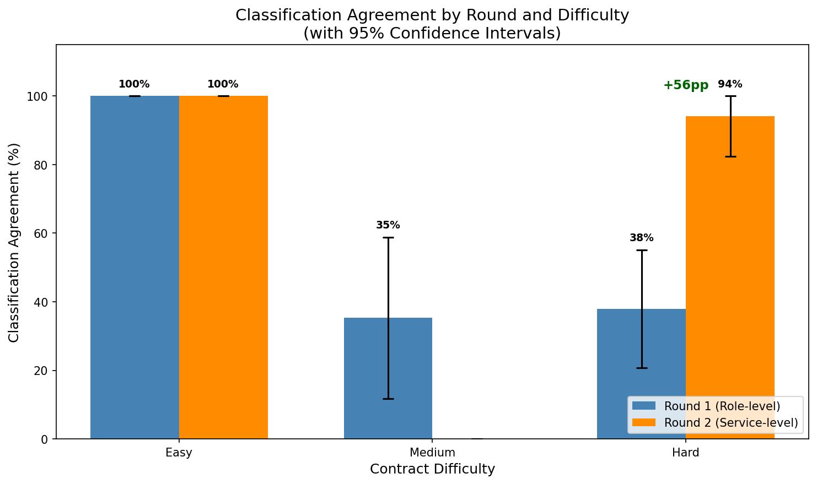
Classification agreement for Hard contracts improved from 38% to 94% when switching from role-level to service-level coding. When two coders independently identify the same service in a contract, they assign identical NAICS codes 94% of the time.
Impact of Coding Method
Switching from role-level to service-level coding improved Hard contract agreement by 56 percentage points.
Figure V: Impact of Coding Method
Metric | Round 1 (Role-Level) | Round 2 (Service-Level) | Change
Hard Contract Agreement | 37.9% | 94.1% | +56pp
Number of Overlapping Services | 29 | 17 | -
Role-level coding requires coders to infer: “This person is a maintenance technician, but what service do they support?” Different coders make different inferences. Instead, service-level coding asks directly: “What services are covered by the contract,” removing the inference step.
Figure VI: Impact of Coding Method
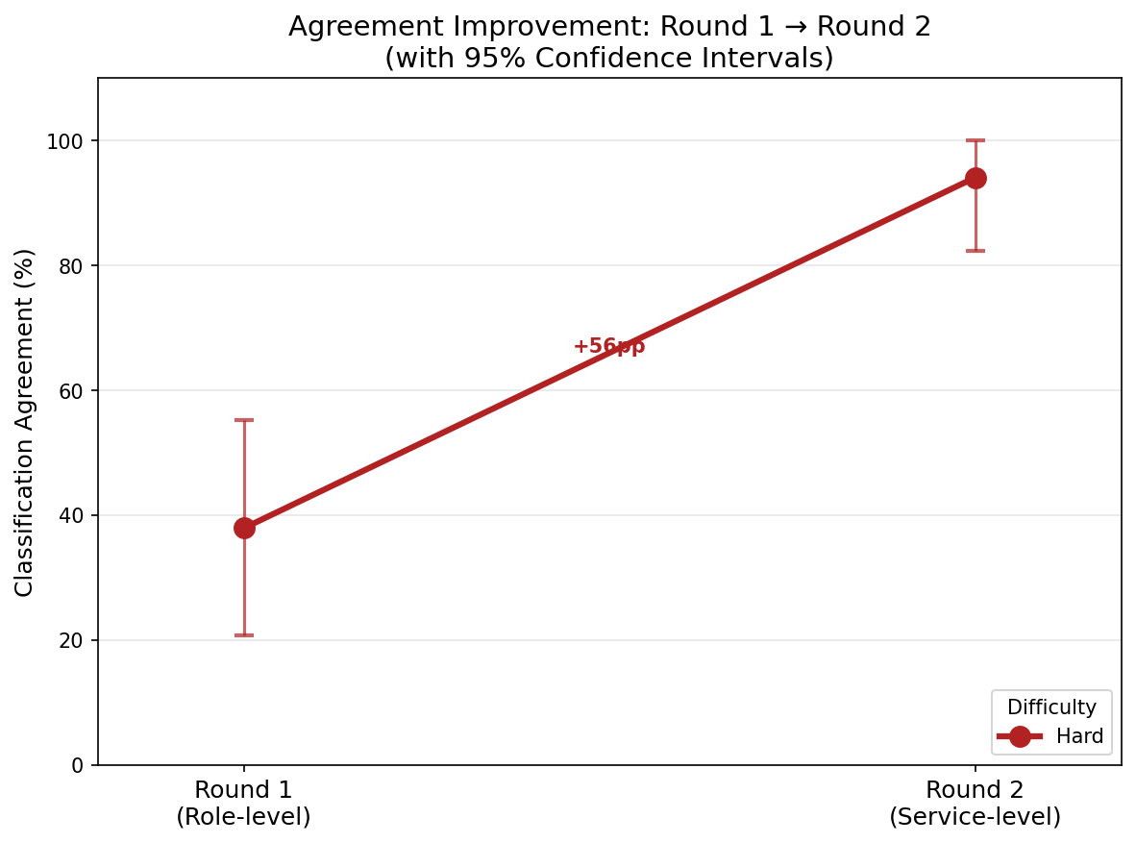
What Causes Disagreements?
Figure VII: Taxonomy of Disagreements
Category | Count | % | Action
Construction vs. Admin (23 <> 56) | 14 | 47% | Handbook rule
Granularity (same prefix) | 11 | 37% | Query on prefixes instead of full codes.
Professional vs. Public Administration (54 <> 92) | 5 | 17% | Handbook rules
Of 30 classification disagreements, 37% were granularity differences within the same code family (low search impact), and 63% followed addressable patterns.
Construction vs. Administration Example
“Building maintenance” was coded as:
- 236220 (Commercial Building Construction) by one coder
  - Assumption: general building maintenance supports upkeep of municipal buildings best operational match for general building maintenance 236220
- 561210 (Facilities Support Services) by one coder, and
  - Assumption: general building maintenance supports upkeep of municipal buildings best operational match for general building maintenance 561210
- 237310 (Highway/Road Construction) by the last coder
  - Assumption: building maintenance is specific to the road division of the public works department most specific operational match 237310
Coders disagreed on whether building maintenance employees “do construction work” (23xxxx) or “support facilities” (56xxxx.) Ambiguities like these are addressed by handbook rules.
For example:
- Construction (23xxxx): use when the role directly performs physical construction
- Support (56xxxx): use when the role supports operations but doesn’t perform construction
- A “maintenance technician” working on roads 237310
- A “maintenance technician” managing work orders 561210
How Does Disagreement Affect Search Results?
Significant but concentrated impact. Single-coder production would miss approximately 30% of query-relevant services overall. This risk is concentrated in specific query categories (Repair: 50%, Support: 46%.)
We designed 36 realistic researcher queries across 8 categories (Construction, Public Administration, Support Services, Utilities, Professional, Recreation, Repair, Transportation) against all 10 coded contracts. For each query-contract pair, we measured whether each coder’s codes would return the contract in search results. The “union” represents the combined set of all three coder’s code sets. “Misses” represent what a single coder would fail to capture relative to the combined “union” set (i.e., treating the “union” for each contract as the canonical truth of all the NAICS codes that could represent the contract, how did each coder compare?)
Figure VIII: Summary of Simulation Results
Metric | Value | 95% CI
Total queries tested | 35 | -
Query-contract combinations (queries * contracts) | 350 | -
Union hits | 112 | -
Average single-coder miss rate | 30.4% | [24%, 37%]
Figure IX: Miss Rates By Category
Category | Union Hits | Avg. Miss Rate | 95% CI | Risk Level
Repair | 6 | 50.0% | [28%, 72%] | HIGH
Support Services | 13 | 46.2% | [31%, 62%] | HIGH
Transportation | 1 | 33.3% | [0%, 100%] | Low n
Professional | 3 | 33.3% | [0%, 67%] | Low n
Public Administration | 5 | 26.7% | [7%, 47%] | Medium
Construction | 29 | 23.0% | [15%, 32%] | Moderate
Recreation | 3 | 22.2% | [0%, 45%] | Low n
Utilities | 5 | 13.3% | [0%, 33%] | Low
Figure X: Miss Rates By Category 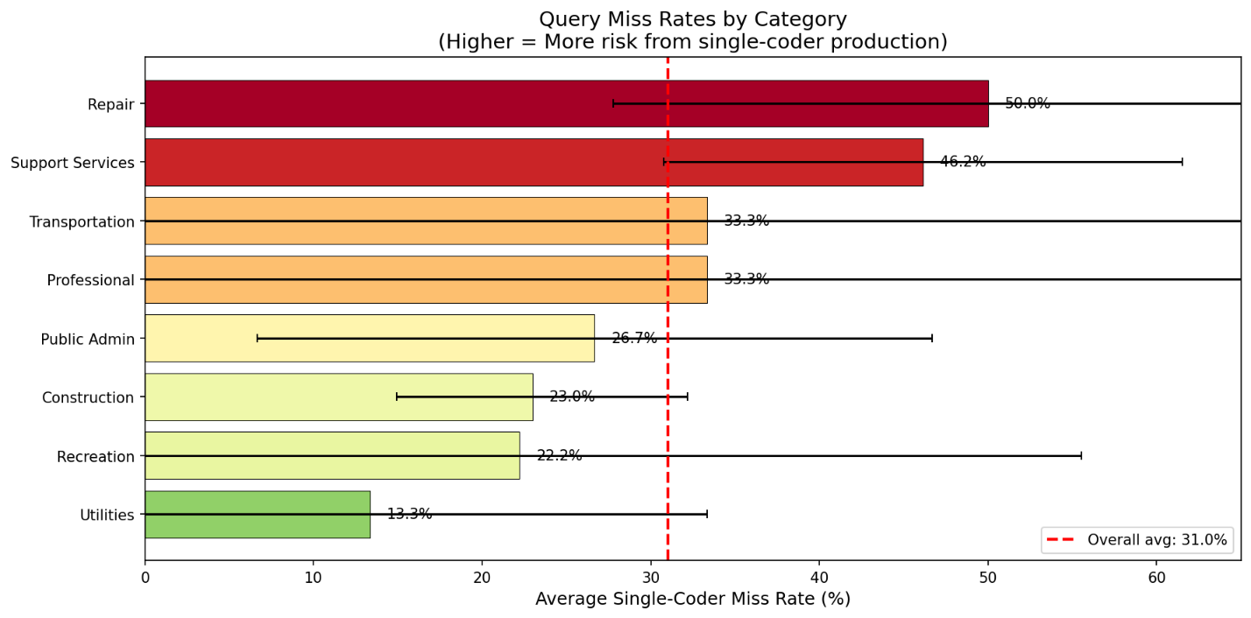
Figure XI: Miss Rates By Category By Coder
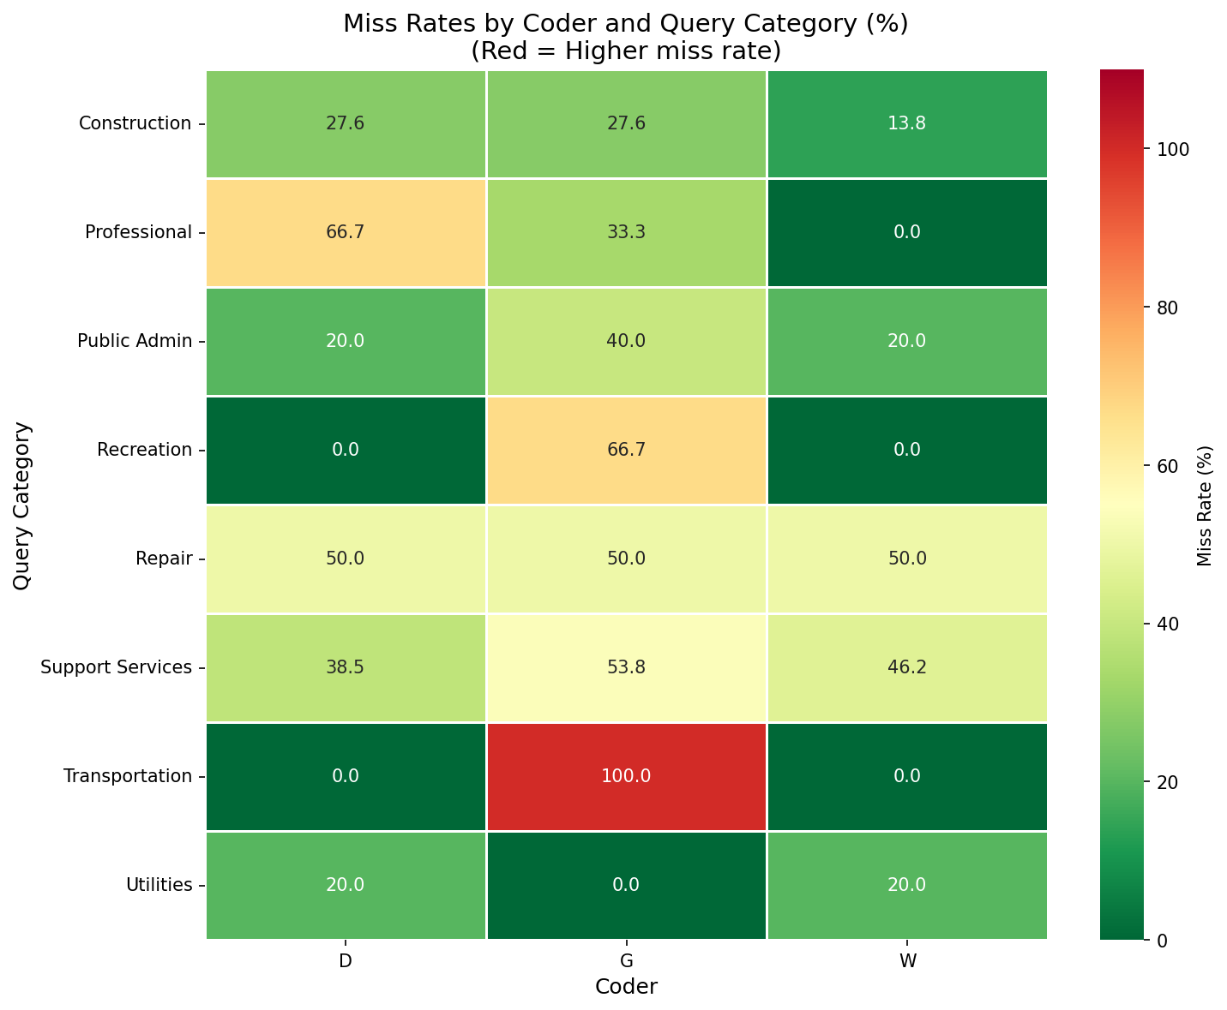
Where did disagreement come from?
- What disagreement patterns emerge?
- How would disagreement impact query performance?
- Do the results support the case for multi-service coding?

Data Structure
Three coders assessed 10 contracts across two distinct coding rounds.
Table I: Data Structure
Round | Approach | Number of Contracts | Description
1 | Role-level | 7 | Coders list job titles and assign a code for each role or group of roles
2 | Service-level | 3 | Coders identify high-level public services and assign a code for each service

Dataset
Each row represents one coder’s classification of one role/service in one contract.
- Many rows per contract (coders identified multiple services)
- Unequal numbers of rows per coder per contract (coders identified different counts of services)
- Some Service_Raw (plain-text identified service) are consistent across coders; others are unique to one coder
- In some cases, NAICS_Raw contains semicolon delimited multiple codes (when a coder associated multiple codes with one identified Service_Raw)
- 272 total observations (203 in Round 1, 69 in Round 2).

Two Stages of Agreement
Instead of raters coding identical items, coders engaged in two sequential tasks:
- Identification: coders independently extract roles/services from contract text
- Classification: coders assign NAICS codes to each identified item
Disagreement can happen at either stage. Coders may identify different services entirely (identification disagreement) or identify the same service but assign different codes (classification disagreement.)

Coder Tendencies
All three coders share the same top 5 code families, but with different proportions:
Table II: Coder Tendencies
Coder | 23xxxx: Construction | 92xxxx: Public Admin | 56xxxx: Administrative and Waste | 54xxxx: Professional, Scientific, Technical | 22xxxx: Utilities
Dylan | 33% | 28% | 18% | 4.5% | 5.4%
Greg | 41% | 24% | 12% | 7.1% | 5.9%
Will | 30% | 30% | 12% | 12% | 4%

- Dylan favors Administrative codes (56xxxx) at 18% vs ~12% for others
- Greg favors Construction codes (23xxx) at 41% vs ~30-33% for others
- Will has most balanced 23/92 split (30%/30%)
- Coder calibration re: when to use different families could reduce disagreementAll three coders used the following families at least once: '22', '23', '48', '54', '56', '71', '81', '92'

Analysis of Identification Overlap
Table III: Service Identification Agreement
How often did coders extract the same service from the contract?
Metric | Round 1 (Role-Level) |  | Round 2 (Service-Level)
All 3 coders identified service |  | 13% |  | 8%
Only 1 coder identified service |  | 58% |  | 70%

Identification Drives Variance
- Most disagreement comes from identification (what services exist), not classification (what code fits a given service)
- Different coders extract different information from the same document
- Handbook should standardize service identification criteria

Analysis of Classification Agreement
Table IV: Service Classification Agreement (Pre-Normalization)
Given agreed service, how often do coders classify the same code?
Round | Agreement Rate |  | n (overlapping services)
Round 1 |  | 49% |  | 53
Round 2 |  | 93% |  | 15
Table V: Service Classification Agreement (Normalized)
Round | Agreement Rate |  | n (overlapping services)
Round 1 |  | 48% |  | 56
Round 2 |  | 94% |  | 18
Table VI: Classification Agreement By Difficulty
Difficulty | Agreement Rate |  | n (overlapping services) |  | 95% CI
Easy |  | 100% |  | 11 | [100%, 100%]
Medium |  | 35% |  | 17 | [11.8%, 58.8%]
Hard |  | 58% |  | 46 | [43.5%, 71.7%]
Table VII: Round X Difficulty Breakdown (Normalized)
Round | Difficulty |  | Agreement |  | n
1 |  | Easy |  | 100% | 10
1 |  | Medium |  | 35% | 17
1 |  | Hard |  | 37% | 29
2 |  | Easy |  | 100% | 1
2 |  | Medium |  | - | 0
2 |  | Hard |  | 94% | 17
Methodology and Framing Matter More than Difficulty
- Round 1 Round 2 agreement, Hard Contracts Only: 37% 94%
- Service-level coding approach is viable for difficult contracts

Query Performance Simulation
Simulate query results from the coding exercise based on the following simulated searches:
Table VIII: Query Simulations
Target Service | Codes Searched | Prefixes Searched
Road Maintenance | 237310 | 237
Police | 922120 | 922
Water utilities | 221310 | 221
Sewer | 221320, 237110 | 221, 237
Fire | 922160 | 922
Parks and recreation | 712190, 713940, 561730 | 712, 713, 561
Building maintenance | 236220, 561210 | 236, 561
Public administration | 921130, 921190 | 921
Professional services | 541330, 541730, 541512 | 541
Corrections | 922140 | 922
Table IX: Simulation Results Per-Contract
Contract | Difficulty | Union Hits | Dylan Miss Rate | Greg Miss Rate | Will Miss Rate
2023-03660-000 | Easy | 2/10 | 0% | 0% | 0%
2023-05433-000 | Easy | 2/10 | 0% | 0% | 0%
2025-00926-000 | Medium | 7/10 | 0% | 0% | 57%
2019-04459-000 | Medium | 5/10 | 0% | 40% | 20%
2025-03668-000 | Hard | 9/10 | 0% | 0% | 0%
2025-03419-000 | Hard | 9/10 | 0% | 33% | 11%
2023-01776-000 | Hard | 9/10 | 11% | 0% | 0%
2025-04120-000 | Easy | 2/10 | 0% | 0% | 0%
2025-04184-000 | Hard | 10/10 | 0% | 10% | 0%
Table X: Miss Rates
Difficulty | Avg. Single Coder Miss Rate
Easy | 0%
Medium | ~18%
Hard | ~14%
Average | ~10%-11%
Where Did Disagreement Come From?
Disagreement can occur at the identification stage (do two coders identify the same services) and the classification stage (given the same identified service, do two coders assign the same code?)

Table I: Identification Overlap
How often did different coders identify the presence of a given public service?
Metric | Round 1 (Role-Level) | Round 2 (Service-Level)
All 3 Coders Identified Service | 13% | 8%
Only 1 Coder Identified Service | 58% | 70%

Most variance comes from identification, not classification (i.e., once two coders agree on an identified service, there is less variance in how they classify that service.) This reflects different thoroughness levels while indicating that the handbook is effective once coders agree on the identified service. For example, Dylan consistently identified more items than Will; variance didn’t come from their disagreeing on which code represents each service, but from whether the service was present and distinct enough to deserve a code.
While overall agreement appears low, much of it is because different coders extracted different information from the same document (i.e., is service X obvious enough from the text of contract Y that I should identify it, or is it small enough to be folded into a different service?)
Table II: Classification Overlap
Given the same public service, how often did different coders arrive at the same code?
Metric | Round 1 (Role-Level) | Round 2 (Service-Level)
Overall agreement | 49% | 87%
Easy Contracts | 100% | 100%
Hard contracts | 39% | 86%

The mental frame and approach to coding dramatically affects agreement on classification after there is already agreement that a given service has been identified.
Bottom Line: Variance in coding came primarily from: (1) different identification thoroughness, and (2) role-level coding forcing coders to infer “which service does this role support?” When using service-level coding on hard contracts, classification agreement reached 86%.

What Patterns Emerge?
Table III: Taxonomy Of Disagreements
Total disagreements across both rounds: 29
Category | Count | % | Impact
Granularity (same idea/prefix, different grouping) | 11 | 38% | LOW: same code family, looser queries solve problem
Support roles | 7 | 24% | FIXABLE: better handbook guidance
Operational vs. Admin | 6 | 21% | FIXABLE: clearer operations vs. admin test
Infrastructure confusion | 2 | 7% | FIXABLE: better handbook examples
Typo/Other | 3 | 10% | MINIMAL, typos FIXABLE

Disagreement is concentrated and predictable. 38% are low-impact granularity differences (e.g., 541512 vs. 541513 both represent computer services; better training can reduce these disagreements; queries for the 5415 prefix capture all computer-related roles.) 45% of disagreements are fixable with clearer handbook rules for support roles and use of operational vs. administrative codes.~80% of disagreement in total is either low-impact or addressable.
Table IV: Coder Tendencies
How did different coders use different NAICS families?
Coder | 23xxxx: Construction | 92xxxx: Public Admin | 56xxxx: Administrative and Waste | 54xxxx: Professional, Scientific, Technical | 22xxxx: Utilities
Dylan | 33% | 28% | 18% | 4.5% | 5.4%
Greg | 41% | 24% | 12% | 7.1% | 5.9%
Will | 30% | 30% | 12% | 12% | 4%
In Dylan’s notes, she noted “I started using your NAICS menu but ultimately felt 92xxxx codes felt better.” Coders have systematic tendencies reflecting different interpretations of the guidelines. These tendencies represent clear interpretive differences that can be addressed through training and clearer guidance.

WORKING ABOVE THIS LINE, EVERYTHING BELOW IS NOTES FOR FUTURE

Analysis Framework
Level of Analysis | Unit of Analysis | Question Answered
Contract-level | The contract as a whole | Overall, do coders agree on what NAICS codes apply to a given contract?
Service-level | Overlapping services (identified by 2+ coders) | When coders identify the same service, do they classify it the same way?
Code-level | Individual codes | Which codes are confused with which after the service is identified?

